**Frontend Development with React.js - Project Documentation**

**Introduction:**

***Project Title*: Insight stream:** Navigate the news

***Team Members and Team members roles*:**

**Pavithra M and Sindhuja K :** Code running and git up link

**Mownisha R :** Voice over

**Preetha V and Sarvaga S :** Document link

**Project Overview**

***Purpose*:**

--- InsightStream is a modern web application designed to revolutionize news consumption.

--- It provides an intuitive interface, advanced search, and diverse categories.

***Features*:**

--- Fetch and display news from external APIs.

--- Categorized news sections (e.g., Politics, Technology, Sports, etc.).

--- Search functionality for specific news topics.

--- User-friendly UI with a modern and intuitive design.

--- Mobile-responsive layout for seamless access on all devices.

**Architecture:**

***Component Structure*:**

--- Outline the major components and their roles (e.g., Navbar, HeroSection, NewsCard, Footer).

--- Explain the interaction between components using a diagram if necessary.

***State Management*:**

--- Explain the use of Context API, Redux, or local component states.

--- Define global and local state usage in different components.

***Routing*:**

--- Describe routing implementation using react-router-dom.

--- Define different page routes (e.g., Home, Categories, Article Details).

**Setup Instructions:**

***Prerequisites*:**

Node.js and npm installed (<https://nodejs.org/en/download/>).

A code editor like Visual Studio Code (https://code.visualstudio.com/download).

Git for version control (https://git-scm.com/downloads).

***Installation*:**

**1. Clone the repository:**

git clone [repository URL]

cd [project-folder]

**2. Install dependencies:**

npm install

3. Configure environment variables (e.g., API keys).

**4. Start the development server**: npm start

**Folder Structure:**

project-folder/

│── src/

│ ├── components/ # Reusable components (Navbar, Footer, etc.)

│ ├── pages/ # Page components (Home, Category, ArticleDetails)

│ ├── context/ # State management (Context API)

│ ├── assets/ # Static assets (images, icons, etc.)

│ ├── styles/ # CSS files for styling

│ ├── App.js # Main app component

│ ├── index.js # Entry point

│── public/ # Public assets

│── package.json # Dependencies and scripts

│── README.md # Project documentation

***Client Folder*** (/src/client/)

The client folder manages API interactions and configurations, ensuring clean separation of concerns. It includes:

apiClient.js – A centralized file for handling API requests using Axios.

config.js – Stores API keys, base URLs, and other environment configurations.

***Utilities Folder*** (/src/utils/)

The utils folder contains reusable helper functions for better code organization. Some examples include:

formatDate.js – Formats timestamps into human-readable dates.

debounce.js – Implements a delay for functions like search to prevent excessive API calls.

storage.js – Manages local storage operations (saving/retrieving user preferences).

***Hooks Folder*** (/src/hooks/)

The hooks folder stores custom React hooks for reusable logic, such as:

useFetch.js – A custom hook for fetching API data with loading and error handling.

**Running the Application:**

Run npm start to start the frontend development server.

Open http://localhost:3000 in the browser to access the app.

**Component Documentation:**

***Key Components:***

Navbar.js - Handles navigation and search.

HeroSection.js - Displays trending news.

NewsCard.js - Represents individual news articles.

Footer.js - Contains app footer information.

***Reusable Components****:*

Button.js - Customizable button component.

Loader.js - Loading animation for API calls.

**State Management:**

***Global State***(Context API / Redux):

Stores fetched news articles.

Manages user preferences like selected categories.

***Local State*(useState Hook):**

Handles search queries.

Toggles UI elements like modals and dropdowns.

**User Interface:**

The application features a clean and intuitive UI with a responsive design for mobile, tablet, and desktop users. Key components include a Navbar for navigation, a Hero Section for trending news, News Cards for articles, a Search Feature, and Category Sections for easy content discovery. The UI supports dark mode, animations, and lazy loading for performance optimization. Error handling ensures smooth functionality. Screenshots and a live demo showcase the interface. The design prioritizes accessibility, user engagement, and seamless interaction.

**Styling:**

Styling plays a crucial role in enhancing the user experience. The project follows a structured approach to maintain clean, reusable, and scalable styles.

***CSS Frameworks/Libraries Used*:**

**Tailwind CSS:** Used for utility-based styling, ensuring rapid development with minimal custom CSS.

**Bootstrap:** Helps with responsive layouts, grid systems, and pre-styled components.

**Styled Components:** If used, provides CSS-in-JS styling for dynamic and modular styling.

**SASS/SCSS (Optional):** If used, allows for better modularization and nesting of styles.

***Theming*:**

Light and Dark mode support using CSS variables (:root { --primary-color: #fff; }).

Custom fonts from Google Fonts for improved typography.

Media queries for responsive design ensuring the app is mobile-friendly.

**Component-Level Styling**:

Each component has its own.css or .scss file to maintain modularity.

Use of classnames package to conditionally apply styles.

**Testing:**

Testing ensures the stability and reliability of the application. The project follows a multi-layered testing approach.

***Testing Strategy*:**

**1. Unit Testing:**

Tests individual React components using Jest and React Testing Library.

**Example:**

import { render, screen } from "@testing-library/react";

import Navbar from "../components/Navbar";

test("renders the Navbar component", () => {

render(<Navbar />);

expect(screen.getByText(/Home/i)).toBeInTheDocument();

ration Testing: });

**2. Integration Testing:**

Ensures data fetching from the API works correctly.

Verifies state updates and interactions between components.

**3. End-to-End (E2E) Testing:**

Conducted using Cypress or Playwright to simulate real-world user interactions.

***Code Coverage*:**

Ensuring adequate test coverage using Jest's coverage tool:

jest --coverage

Measuring component-level and API request coverage to identify untested areas.

**Performance Testing**:

Lighthouse audit to optimize rendering and speed.

Use of React DevTools to monitor component performance.

**Screenshots or Demo:**

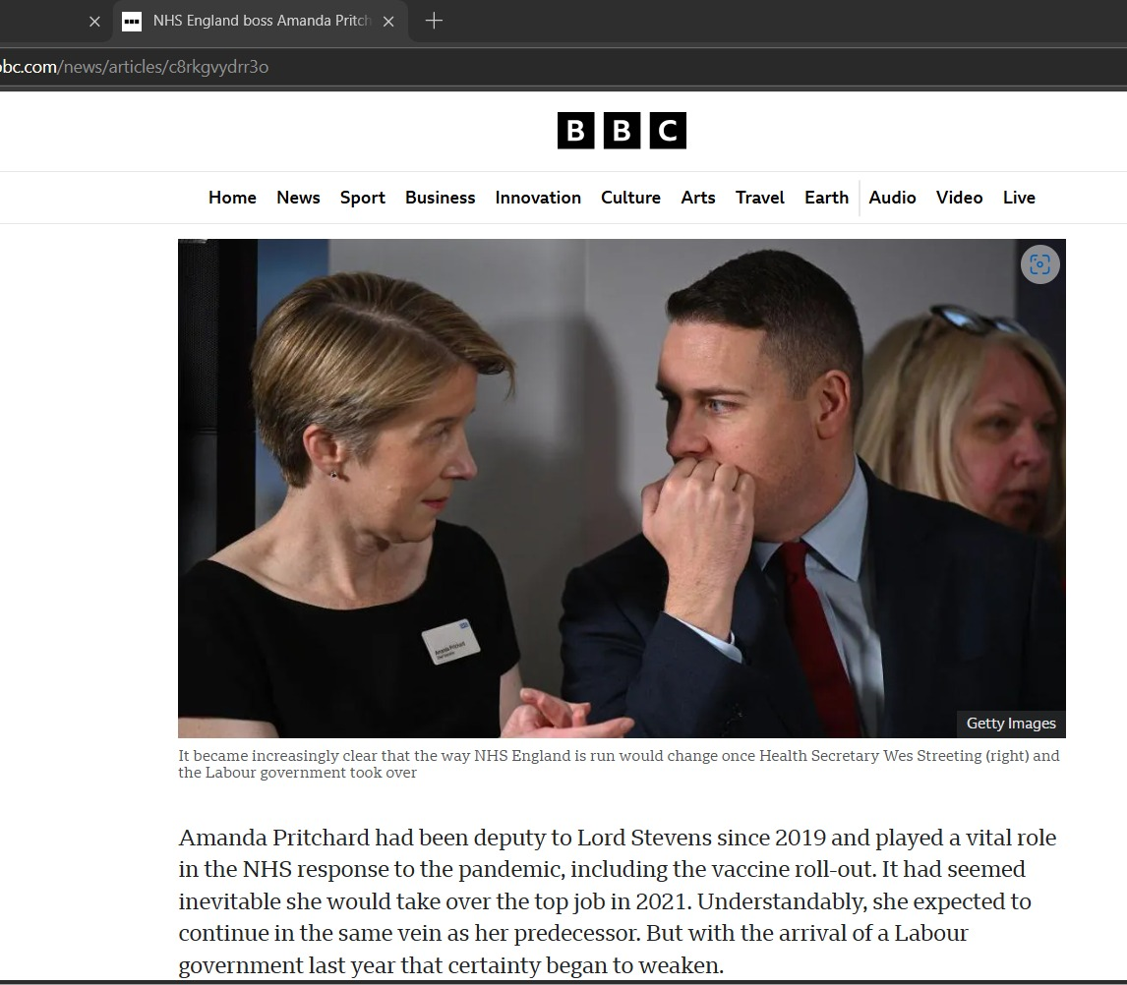

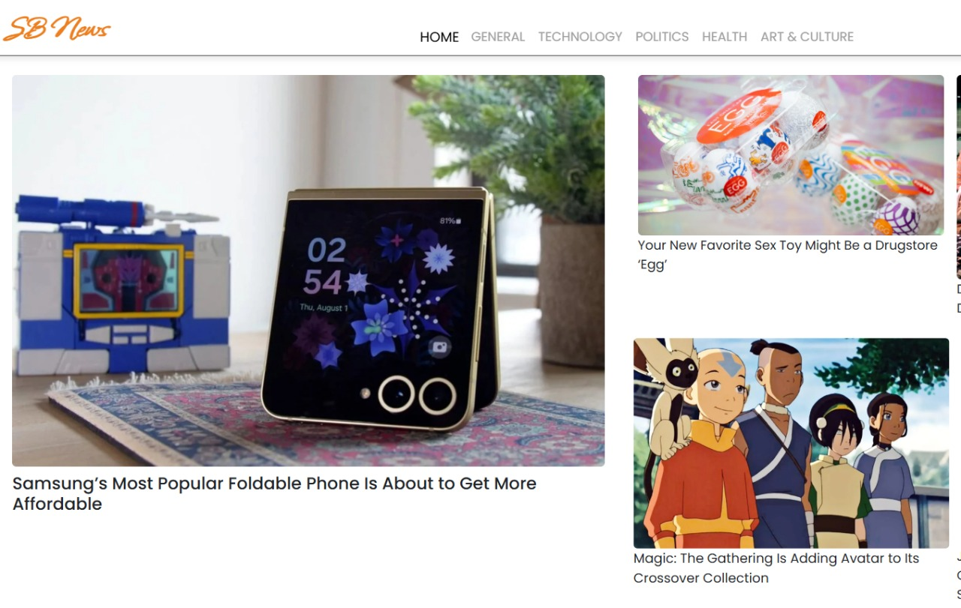



**Known Issues:**

While the application functions smoothly, there are some known challenges and limitations:

**1. API Rate Limitations:**

Free-tier APIs like newsapi.org may have request limits, affecting performance during high usage.

Solution: Implement caching or a backend proxy.

**2. Search Functionality Latency:**

Due to real-time API calls, there might be slight delays in displaying results.

Solution: Debounce search inputs using lodash.debounce.

**3. Dark Mode Compatibility Issues:**

Some elements might not display correctly when switching between light and dark modes.

Solution: Ensure consistent use of CSS variables for theme switching.

**4. Mobile Responsiveness Bugs:**

Certain layouts might break on smaller screens.

Solution: Conduct thorough testing across …

**Future Enhancements:**

To improve functionality and user experience, the following features are planned:

**1. User Authentication System:**

Implement user login via Firebase/Auth0 for personalized news feeds.

Allow users to bookmark and save articles.

**2. Offline Mode Support:**

Enable caching of news articles for offline reading.

**3. AI-Based News Recommendations:**

Use machine learning (ML) to recommend personalized news based on user interests.

**4. Push Notifications for Breaking News:**

Implement Web Push API to notify users about trending stories.

**5. Multi-Language Support:**

Add translations for global audiences.

**6. Enhanced UI/UX Animations:**

Use Framer Motion for smooth transitions and micro-interactions.

**7. Integration with Social Media**:

Enable users to share articles on platforms like Twitter and Facebook.